Topic 4: Multiple Regression Analysis

1. Introduction
Multiple Regression Analysis (MRA) is a dependence technique used to examine the relationship between one metric dependent variable and two or more independent variables.
The technique serves two main purposes:
- Prediction – estimating the value of a dependent variable using known values of predictors.
- Explanation – assessing the relative contribution and direction of influence of independent variables.

2. Conceptual Framework
2.1 Simple vs Multiple Regression
Aspect | Simple Regression | Multiple Regression
Number of IVs | One | Two or more
Objective | Basic prediction | Enhanced prediction and explanation
Model complexity | Low | Higher
Risk of multicollinearity | None | Present

2.2 The Regression Variate
In multiple regression, the regression variate is a linear combination of independent variables that best predicts the dependent variable.
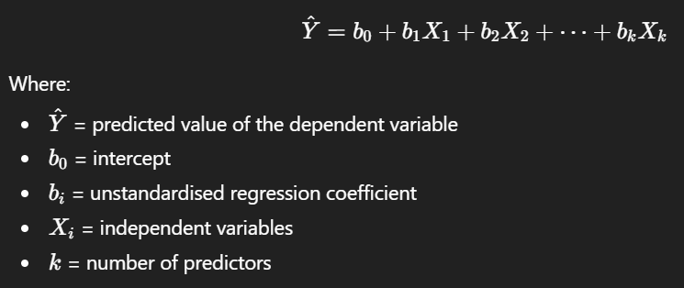

3. Interpretation of Regression Coefficients
3.1 Unstandardised Coefficients, b
- Represent the expected change in the dependent variable for a one-unit change in the independent variable.
- Interpretation is scale-dependent.

  - Standardised Coefficients β\betaβ
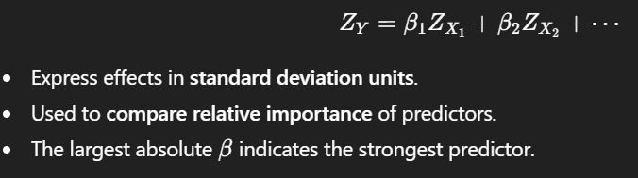

4. Model Evaluation
4.1 Goodness of Fit
Coefficient of Determination
R Square = Explained Variance / Total ​
- Indicates the percentage of variance in Y explained by all IVs combined.
- Always increases when IVs are added.
Adjusted R Square
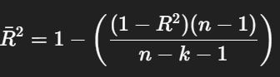
- Penalises unnecessary predictors.
- Preferred for model comparison.

4.2 Overall Model Significance
F-test
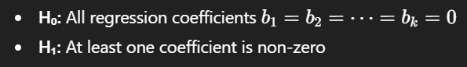
Decision rule:
- If p-value < 0.05, the regression model is statistically significant.

5. Assumptions of Multiple Regression
Multiple regression relies on four core assumptions.
5.1 Linearity
- Relationship between each IV and DV must be linear.
- Diagnosed using:
  - Scatterplots
  - Partial regression plots

5.2 Homoscedasticity
- Constant variance of residuals across predicted values.
Test and diagnosis:
- Residuals vs fitted values plot
- Breusch–Pagan test
Implication of violation:
- Standard errors become biased.

5.3 Normality of Errors
- Residuals should follow a normal distribution.
Tests:
- Shapiro–Wilk test
- Kolmogorov–Smirnov test
Rule of thumb:
- Serious only in small samples n≤50.

5.4 Independence of Errors
- Residuals must not be correlated.
- Particularly important in time-series data.
Test:
- Durbin–Watson statistic

6. Multicollinearity
6.1 Definition
- Collinearity: correlation between two IVs
- Multicollinearity: correlation among three or more IVs

6.2 Consequences
- Inflated standard errors
- Unstable coefficient estimates
- Reduced statistical power

6.3 Diagnostics
Measure | Decision Rule
Variance Inflation Factor (VIF) | VIF > 10 indicates serious multicollinearity
Tolerance | < 0.10 problematic

7. Variable Selection Strategies
7.1 Enter Method
- All predictors entered simultaneously.
- Appropriate when theory dictates variable inclusion.

7.2 Stepwise Methods
- Forward selection
- Backward elimination
- Stepwise regression
Advantages:
- Produces parsimonious models
Limitations:
- Sample-specific
- Not theory-driven
- Requires large samples ≥ 50 : 1

8. Sample Size Guidelines
Context | Recommended Ratio
General multiple regression | ≥ 5 observations per IV
Stepwise regression | ≥ 50 observations per IV
Small samples n≤30n \le 30n≤30 | Simple regression only

9. Extensions of Multiple Regression
9.1 Dummy Variables
Used to incorporate nonmetric predictors.
- A categorical variable with k categories requires k−1 dummies.
- Coefficients represent group differences relative to the reference category.

9.2 Curvilinear Effects
Polynomial regression:
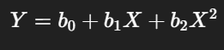
- Captures nonlinear relationships.
- Evaluated using incremental R square.

9.3 Interaction and Moderator Effects
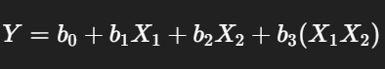
- b3b_3b3​ indicates how the effect of X1X_1X1​ changes with X2X_2X2​.
- Interpretation focuses on change in relationship, not individual coefficients.

10. Model Validation
10.1 Adjusted R2R^2R2
- Indicates model stability.
10.2 Split-Sample Validation
- Estimation sample
- Holdout sample
Ensures generalizability and guards against overfitting.

11. Summary Table
Component | Purpose
Regression equation | Prediction and explanation
R2R^2R2, Adjusted R2R^2R2 | Model fit
F-test | Overall significance
t-tests | Individual predictor significance
VIF, Tolerance | Multicollinearity diagnostics
Residual plots | Assumption checking
Dummy variables | Nonmetric predictors
Interaction terms | Moderation analysis

Exam Revision Notes

1. Definition (Write this in exams)
Multiple Regression Analysis is a dependence technique used to analyse the relationship between one metric dependent variable and two or more independent variables, with the objective of prediction and explanation.

2. Regression Model (Must memorise)
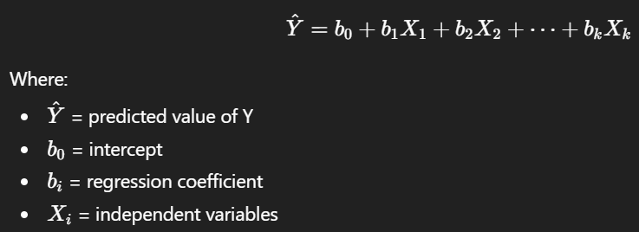

3. Interpretation of Coefficients (Very examinable)
Unstandardised coefficient b
- Unit-based interpretation
- Meaning: expected change in Y for a one-unit increase in X, holding other variables constant
Exam wording:
“Holding other variables constant, a one-unit increase in Xi​ results in a bi​-unit change in Y.”

Standardised coefficient β
- Measured in standard deviation units
- Used to compare relative importance of predictors
- Larger absolute β → stronger predictor

4. Model Fit and Significance
Coefficient of Determination
R Square = Proportion of variance in Y explained by the IVs
- Always increases when IVs are added
- Does not account for model complexity

Adjusted R Square
- Penalises unnecessary predictors
- Preferred when comparing models

Overall Model Test (F-test)
H0: All bi=0
H1: At least one bi Not Equal s0
Decision rule:
- p-value < 0.05 → regression model is statistically significant

5. Individual Predictor Significance
t-test for coefficients
H0: bi=0b
H1: bi≠0b
- p-value < 0.05 → predictor significantly affects Y

6. Assumptions of Multiple Regression (Must list all 4)
1. Linearity
- Relationship between each IV and DV is linear
- Checked using scatterplots or partial regression plots

2. Homoscedasticity
- Constant variance of residuals
- Checked using residuals vs fitted values plot
- Violation → biased standard errors

3. Normality of Errors
- Residuals normally distributed
- Tests:
  - Shapiro–Wilk
  - Kolmogorov–Smirnov
- Critical mainly for small samples n ≤ 50

4. Independence of Errors
- Errors are uncorrelated
- Tested using Durbin–Watson statistic
  - Value ≈ 2 indicates no autocorrelation

7. Multicollinearity (High-probability exam question)
Definitions
- Collinearity: correlation between two IVs
- Multicollinearity: correlation among three or more IVs
Consequences
- Inflated standard errors
- Unstable regression coefficients
- Reduced interpretability of individual predictors
Diagnostics
Measure | Rule
VIF | > 10 problematic
Tolerance | < 0.10 problematic
Key exam line:
“Multicollinearity affects individual coefficients but not necessarily overall model fit.”

8. Variable Selection Methods
Enter Method
- All IVs entered simultaneously
- Theory-driven approach
Stepwise Methods
- Forward selection
- Backward elimination
- Stepwise regression
Limitations (write this):
- Sample-specific
- Not theory-based
- Requires large samples

9. Sample Size Rules (Memorise)
Situation | Rule
General MRA | ≥ 5 observations per IV
Stepwise regression | ≥ 50 observations per IV
Small samples n≤30 | Simple regression only

10. Extensions of Multiple Regression
Dummy Variables
- Used for nonmetric IVs
- Variable with k categories → k−1 dummy variables
- Coefficients represent group differences relative to reference category

Curvilinear Effects (Polynomial Regression)
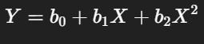
- Models nonlinear relationships
- Evaluated using change in R Square

Interaction (Moderator) Effects
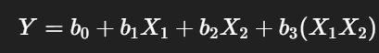
- b3 indicates moderation
- Focus on incremental R Square, not individual p-values

- 11. Model Validation
- Adjusted R Square for stability
- Split-sample validation for generalisability

